
East West University

Department of Computer Science and Engineering
Semester : Spring 2021
Course Title: Electrical Circuits
Course Code: CSE 209
Section: 03

Experiment Number : 06
Experiment Title : Verification of Thevenin’s Theorem.

Student Name : Md. Rakibur Rahman
ID: 2019-3-60-113

Date of Performance : 28 .04 .2021
Date of Submission : 04 .05 .2021

Objective : To verify the Thevenin’s theorem theoretically experimentally, and using PSpice simulation.

Circuit Diagram:
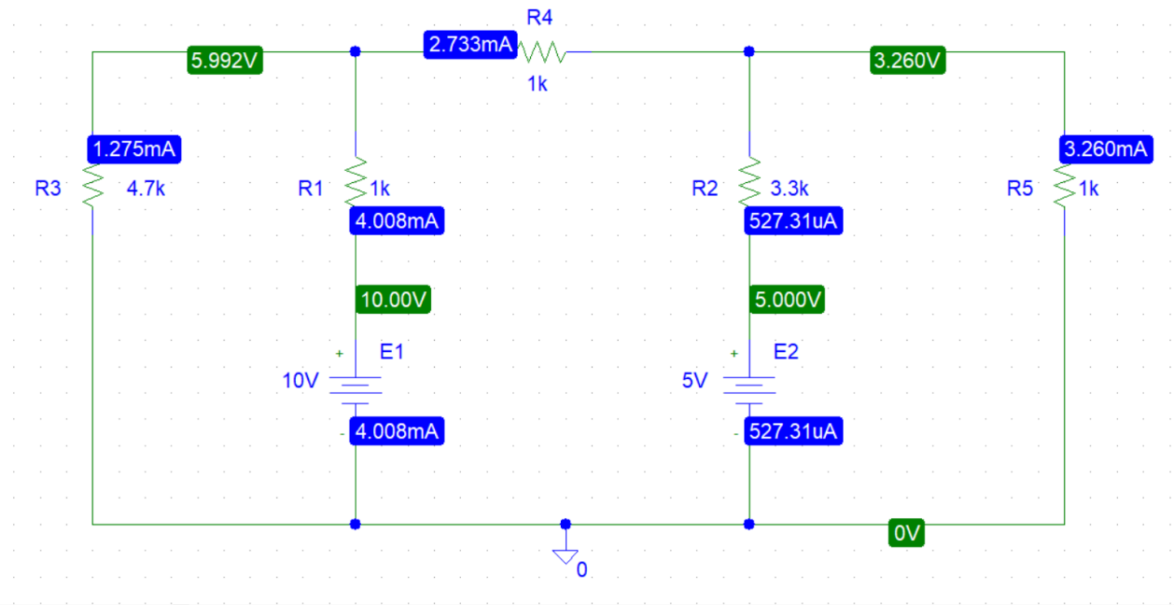
Figure -1
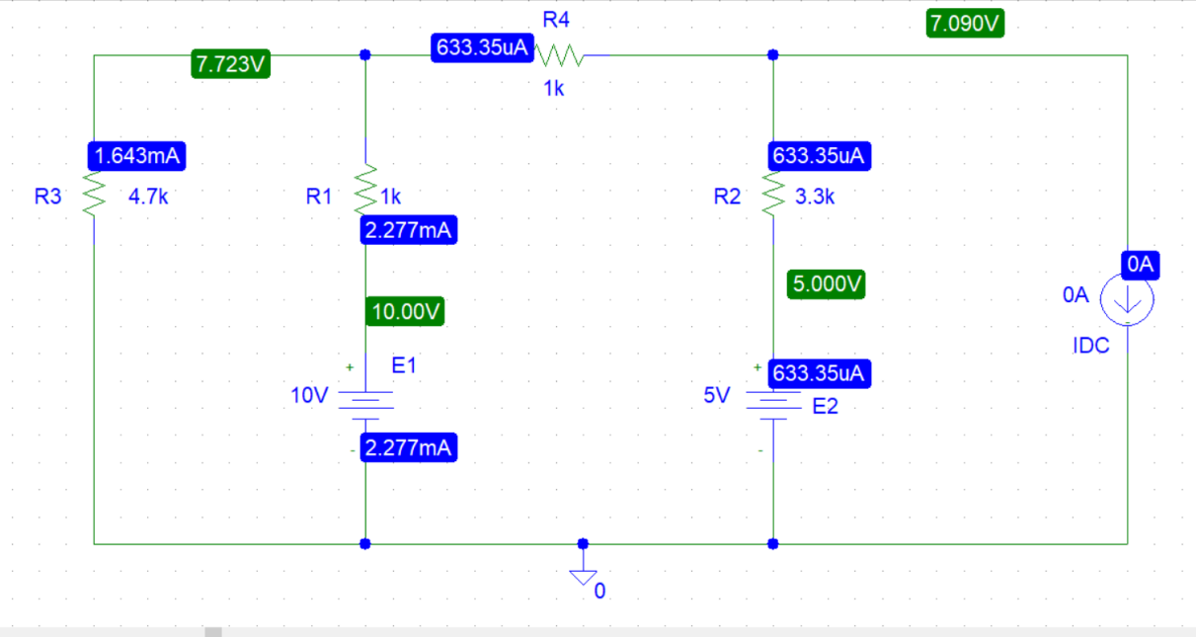
Figure-2

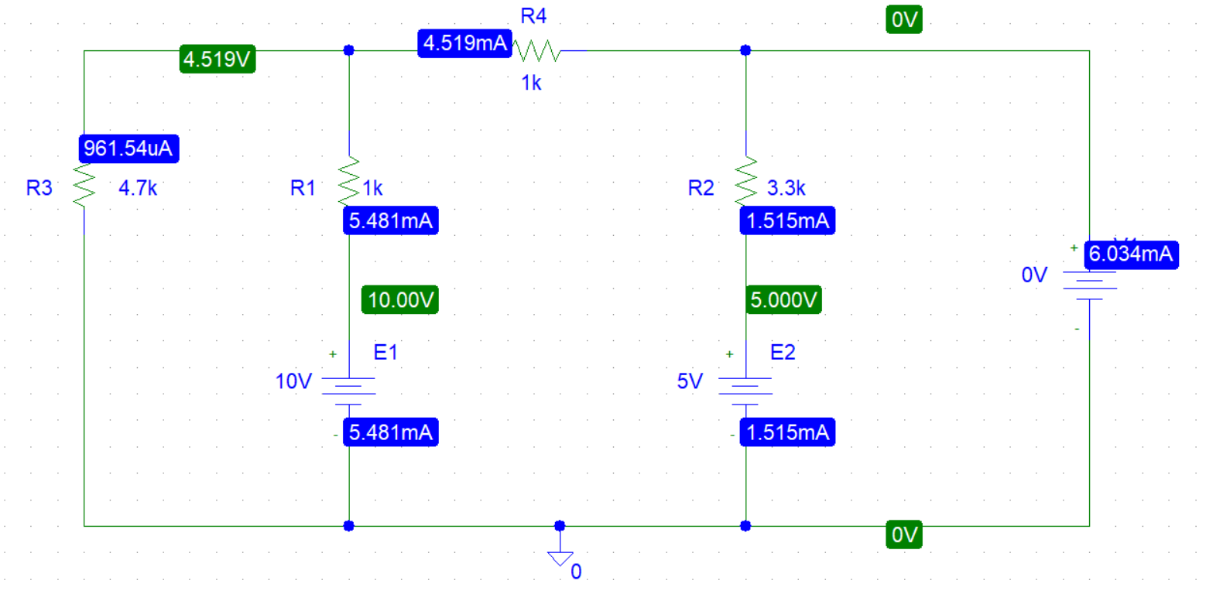
Figure-3
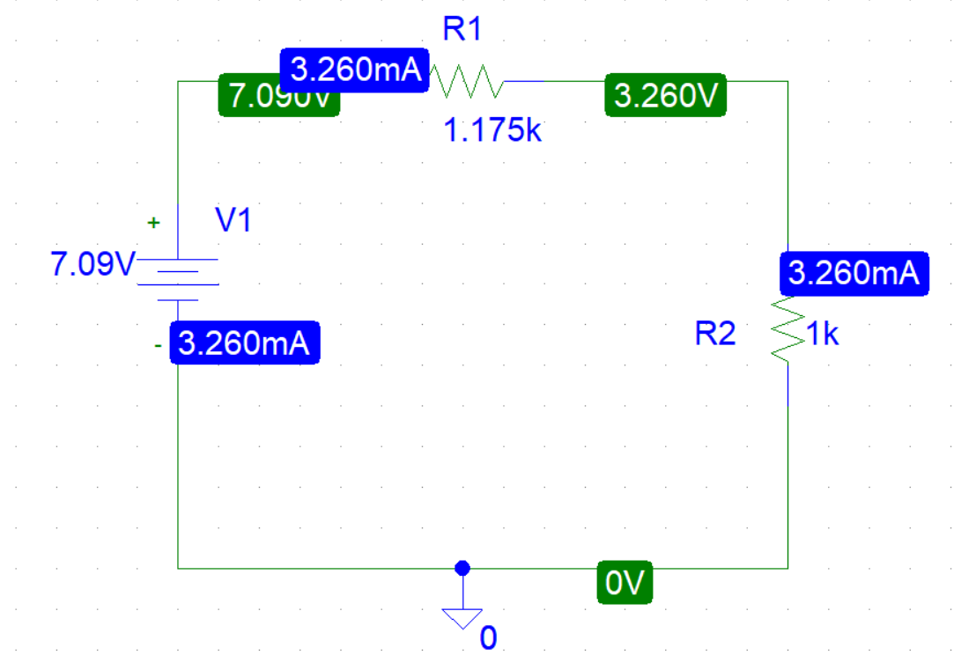
Figure -4

Experimental Datasheet:

Value of E₁ | Value of E₂ | Value of V_{L} | Value of I_{L} | Value of V_{OC} | Value of I_{SC} | Value of Resistors
10 | 5 | 3.260 | 3.260mA | 7.090 | 6.03mA | R₁=1 kΩ  R₂=4.7 kΩ  R₃=3.3 kΩ  R₄ = 1 kΩ  R_{L} = 1 kΩ

Answers to the post lab report questions:

- For figure 1:
Applying KVL at mesh 1,
4.7ki₁ + 1k(i₁- i₂) = -10
5.7ki₁ - 1k i₂ = -10……(1)
Applying KVL at mesh 2,
1k(i₂- i₁) + 1ki₂ + 3.3k(i₂- i₃) = 10-5
-1ki₁ + 5.3ki₂ - 3.3k i₃ = 5……(2)
Applying KVL at mesh 3,
3.3k(i₃- i₂)+ 1k i₃=5
-3.3k i₂+ 4.3k i₃=5……(3)

Solving equation 1,2 & 3,
i₁=-1.275×10⁻³A =-1.275mA
i₂=2.733×10⁻³A =2.733mA
i₃= 3.260×10⁻³A= 3.260mA
here, i₃=I_{L}= 3.260mA
V_{L} =I_{L}× R= 3.260mA× 1kΩ
= 3.260V

For figure 2:
Applying KCL at node 1,
$\frac{V1}{4.7k}$ + $\frac{V1-V2}{1k}$ + $\frac{V1-10}{1k}$ = 0
2.213×10⁻³V₁ - 1×10⁻³V₂ =0.01 ……(1)
Applying KCL at node 2,
$\frac{V2-V1}{1k}$ + $\frac{V2-5}{3.3k}$ = 0
- 1×10⁻³V₁ + 1.30303×10⁻³V₂ =1.51515×10⁻³ ……(2)
Solving equation 1&2,
v₁= 7.723V
v₂=7.090V
here, V_{OC}=V_{th} = V₂= 7.090V

For figure 3:
Applying KVL at mesh 1,
4.7ki₁ + 1k(i₁- i₂) = -10
5.7ki₁ - 1k i₂ = -10……(1)
Applying KVL at mesh 2,
1k(i₂- i₁) + 1ki₂ + 3.3k(i₂- i₃) = 10-5
-1ki₁ + 5.3ki₂ - 3.3k i₃ = 5……(2)
Applying KVL at mesh 3,
3.3k(i₃- i₂)=5
0i₁-3.3k i₂+ 3.3k i₃=5……(3)
Solving equation 1,2 & 3,
i₁=-9.6154×10⁻³A =-0.96154mA
i₂=4.519×10⁻³A =4.519mA
i₃= 6.034×10⁻³A= 6.034mA
here, i₃=I_{SC}= 6.034mA
R_{th} = $\frac{Vth}{Isc}$
=$\frac{7.090}{6.034×10-3}$
=1175 Ω
=1.175 kΩ
And , E_{th}= V_{th}=V_{OC}=7.090V
For figure 4:
Here , I_{L} = $\frac{7.090}{1.175k+1k}$
= 3.260mA
V_{L} =I_{L}× R= 3.260mA× 1kΩ
= 3.260V
Thus, it verifies Thevenin’ theorem.

2. As the experiment was done in PSpice, the values of E ,V & R are same. Thus , there is no discrepancy.

Conclusion: In this experiment we verified Thevenin’s equivalent theorem. Now we can convert two terminal linear circuits into a voltage source in series with a resistance as well as Thevenin’s equivalent circuit.

